Volunteer Registration/Login


Watch for your registration email* from the Girl Scout Cookie Program (email@email.girlscouts.org) Your council will let you know what date to expect that. You will receive your volunteer email before parents have access. Be sure to add that email address to your safe senders list so you don’t miss any emails!
*If you didn’t receive a registration email, please see the “No Registration Email” tip sheet.

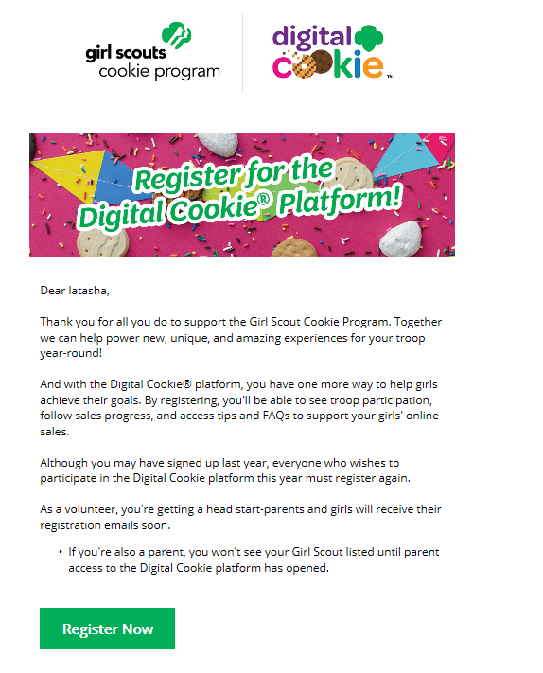


In the email is a “Register Now” button to take you to the Digital Order Card registration site. Simply click that button!
(For best results, use the most up to date version of your web browser)


Once you click the link you’ll be on the Digital Order Card 6.0 site.
You’ll need to create your password.

You will receive a registration confirmation email. Keep it somewhere handy during cookie season.

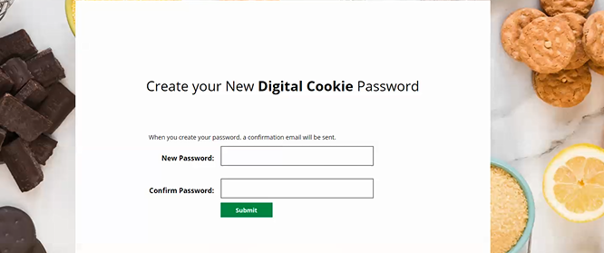


Use your new password to log in. Remember to use the same email address where you received your registration email.
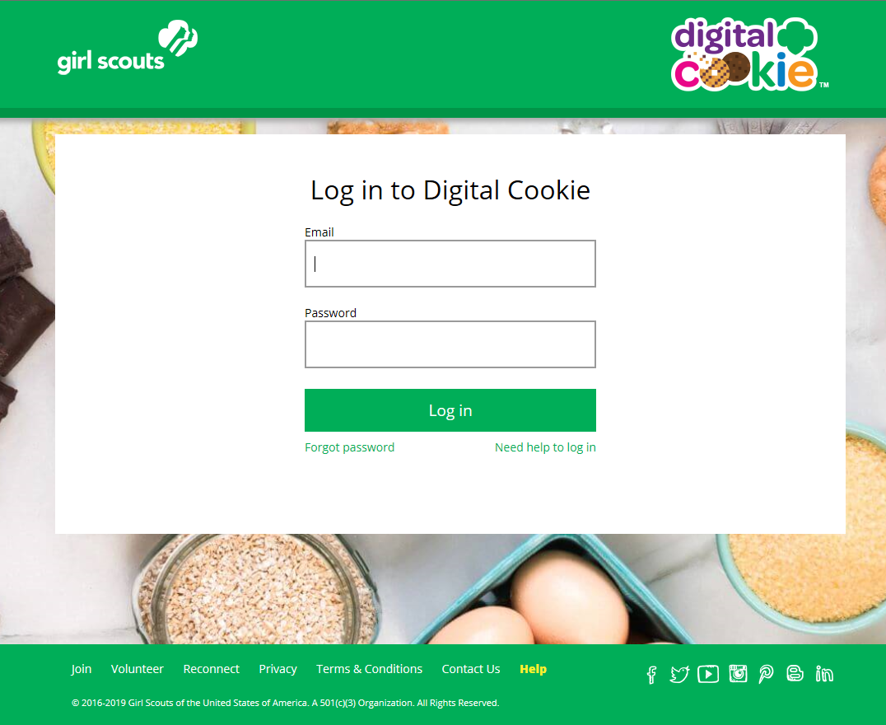


If you are also the parent of a Girl Scout under 13 and parent registration is open, you will then watch a quick “Safe Selling for Smart Cookies” safety video. Note you can’t proceed any further until you have viewed the video.

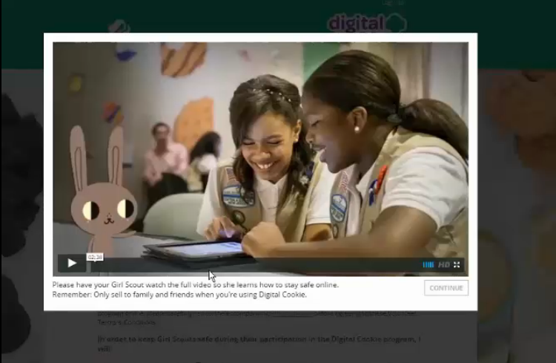


Read and accept the Terms and Conditions-Volunteer. If you are also a parent, you will need to read and accept the Terms and Conditions for parent when parent access opens.
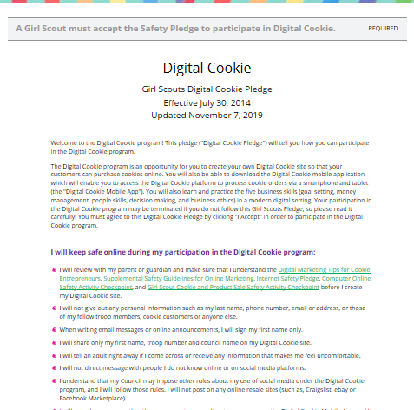

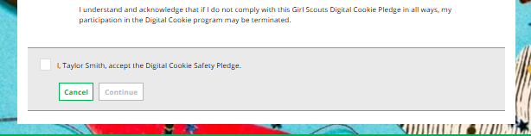
Continue
Accept


If parent registration has opened in your council and you are also a parent of a Girl Scout under 13, you will see the girl pledge appear. If parent access has not opened, you will see it appear on your next login once parent access begins. See the “Site Registration” tip sheet for more information on the pledge.


If you have roles in addition to Troop Leader, you will be taken to a “role selector” screen once parent access opens, which may be a week after your volunteer access.
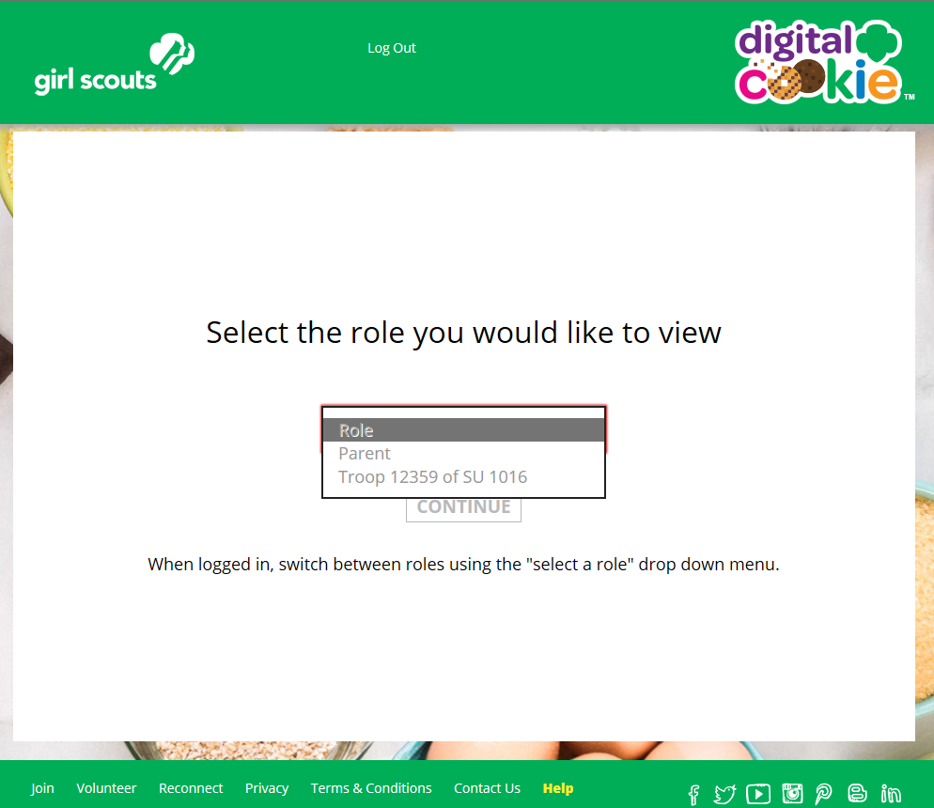
NOTE: If parent access has not opened in your council, you will not see your Girl Scout’s information or be able to access her site until it opens.

Once parent access has begun, if you have additional roles and aren’t taken to this screen OR all of your roles do not show up on the drop down, please contact your Girl Scout Council for assistance.


For information on completing the girl registration process, please see the “Site Registration” tip sheet.

Each time you login you can indicate what role you want in order to get to the correct homepage. You can also navigate to your other roles at the top of all of your screens using the “Select a Role” dropdown.

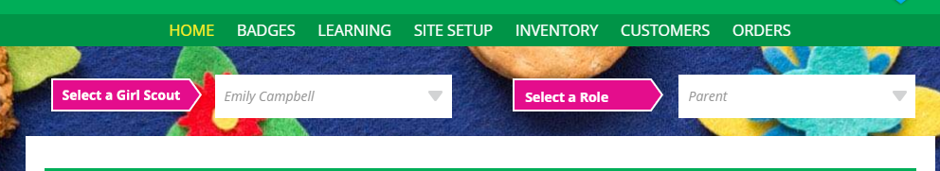

Next Steps: Troop Dashboard tip sheet

